**Device an E-waste management system technologically efficient and eco friendly.**

YASH DESAI

“TECH REBEL”

**Problem Statement:**

With rise in technology and use of ICT infrastructure and other electronic utilizes problem of managing E-WASTE is now a major challenge across the globe. India is among the third country which generates highest e-waste after China and US. E-waste generates toxic chemical which are dangerous to environment. On the contrary, E-WASTE also includes precious metals like gold and silver which must be extracted properly. Build a solution for effective management of e-waste which is technologically efficient and eco-friendly at the same time.

**Why it is necessary to manage E-WASTE ?**

First, we will know what is e waste: - It refers to the electronic items which are not in an ideal condition of usage, like computer, tv, ac, refrigerator, smart phones and other electrical appliances.

* According to a 2020 report by the Central Pollution Control Board, India generated 10 lakh tons of e-waste in FY 2019-2020 which was an increase of 32% from FY 2018-2019; which makes INDIA the third largest E-WASTE generating country after China and USA.
* Still there is no proper management of E-WASTE in our country and we are using the old methods of landfilling to dispose E-WASTE which leads to environmental pollution and various health issues all of this will be taken care of if our model is properly implemented and it will also help in providing employment all of this will be covered in our solution.
* Indium(used in solar cells, LCD screens, computer chips,) tantalum(used in the electronics industry for capacitors and high power resistors), silver electrical contacts , and printed circuit boards), arsenic used to make light-emitting diodes (LEDs)., yttrium(used to produce phosphors that are used in cell phones and larger display screens as well as general lighting), and gallium employed in advanced semiconductors for microwave transceivers, DVD's, laser diodes in compact discs and other electronic applications). These 6 materials are under rising threat of extinction from increased use.

**Overview of Our System:**

Overview of process:

* At the initial stage we will collect e-waste from industries (which produces and collect e-waste) on contractual basis.
* And even for getting small quantities of e-waste from common public we can use hotline system services and web portal.
* This collected e-waste will be transported to workshop for recycling.
* For recycling process, we will require workers which can be from backward classes, below BPL peoples and other citizens in need of employment.
* We will train the hired workers formally so that they can be properly incorporated in our system.
* After proper training, workers will manually separate collected e-waste in two different ways
  + In which one of them will be the type of e-waste which cannot be reused or refurbished and will directly be shredded.
  + In second type of waste workers will manually remove glasses, reusable circuits, motherboards and other metals such as silver, gold etc.
* In the next stage the remaining waste would be dumped into Shredder for further processing.

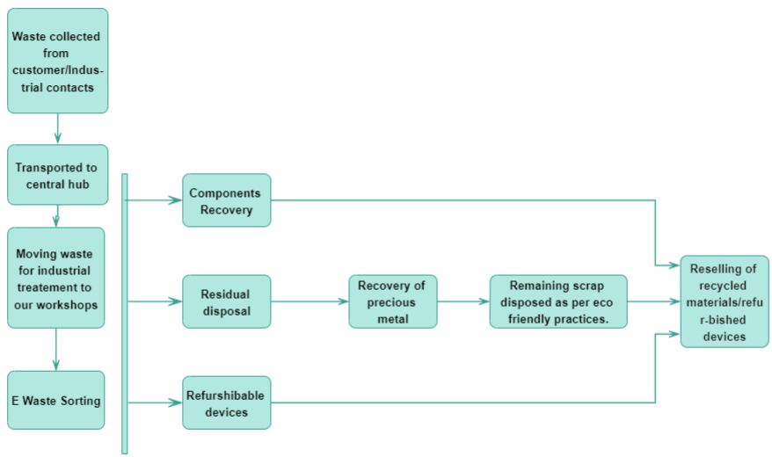

**Treatment of E-WASTE:**

**SHREDDER**

* The shredder will shred the E-WASTE materials into small chunks which will be transported by conveyor belt to an overhead magnet for electromagnetic separation.

**ELECTRO MAGNETIC SEPERATION**

* The overhead magnet will help us in separating steel and iron from the E-WASTE stream and it will be collected at the end of the session for recycling and resold in the market.

**EDDY CURRENT SEPERATOR**

* The remaining materials will go through EDS (EDDY CURRENT SEPERATOR) whose purpose is to Separate nonferrous metals like copper and aluminum and circuit will be separated from the waste. Now for the final step only plastic materials will be left.

**METAL DETECTOR AND AIR JET**

* Now with the help of metal detector we will identify the remaining metals and if any metals were not identified in the previous processes than we will collect them at the end of this process but the main purpose is to obtain pure plastic for recycling in this step.
* The air jet will blow away plastic materials from the metals which are left and plastic will be collected in boxes so that its recycling can be done.
* The residual metals will be scrapped.
* This concludes the industrial treatment of E-WASTE.

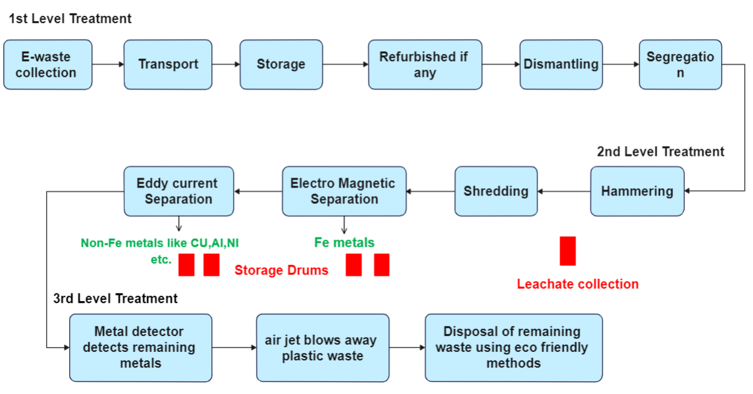

**Selling of recycled materials and Revenue Generation:**

**Selling of E-WASTE**

We have done the recycling of E-WASTE in the previous steps now selling of the recycled materials can be done by following methods: -

1)First by using manual separation we removed glass, and repairable circuits, chipsets and refurbish able devices so we will sell it again in market and it will become our first source of income.

2) The recycled iron and steel will be sold to industries which uses recycled metals, we can also resell it to our industrial sources and provide certain discounts to them which will encourage them to provide us with more E-WASTE materials.

3)The same selling method will be applied to copper and aluminum collected from Eddy current Separator and plastic which is collected in the end.

4)We are also thinking to develop our own recycled products and sell them back using our own website which will help us in earning more profit, if in future we have enough resources, man-power and financial left to be utilized annually.

**The harmful effects of E-WASTE and its Remedies:**

The harmful effect of E-WASTE on our society and how our approach will overcome these issues: -

* The E-Waste stream contains diverse materials — most prominently hazardous substances such as lead, polychlorinated biphenyls (PCBs), polybrominated biphenyls (PBBs), mercury, polybrominated biphenyl ethers (PBDEs), brominated flame retardants (BFRs), and valuable substances such as iron, steel, copper, aluminum and plastics.
* E-waste releases harmful chemicals, such as lead, on burning, which adversely impacts human blood, kidney and the peripheral nervous system. When it is thrown in landfills, the chemicals seep in the ground water affecting both land and sea animals.
* Now instead of landfilling waste if it is recycled using our system than not only will it save the land use for dumping but also soil pollution and the diseases which are caused by it can be abolished.
* Also, employment will be provided to many people which will help in improving their lives.
* According to a study, 5 tons of e-waste, gives a resell value of 2 lakh 88 thousand Rs while its procurement cost is1 lakh 9 thousand (including logistics) that brings us a profit of 1 lakh79 thousand Rs.
* As we already know India produces more than 10 lakh tons of E-WASTE every year so if we manage to properly dispose 30% of it (i.e., 3 lakh tons) initially than every year we will generate a massive.

**CASE STUDY OF GUJARAT STATE**

How our model can be implemented in real life and all of the conditions that are necessary for its smooth operation is answered through the case study that we have done and it will give you further insight about our solution.

**GROWTH RATE**

**3.54 lakh tons e E-Waste is generated in Gujarat.**

It increased by 1.3 lakh tons in 2020-21 to reach a total of **3.54 lakh tons** of e-waste collected and processed. Gujarat generated the greatest amount of e-waste in 2020-21 as compared to other types of wastes.

**FREQUENCY**

The E-waste shall be collected on monthly basis from designated areas and then it would be transferred to sub centers for storing and when a fixed amount of E-waste is collected it will be transferred to Central Hubs for treatment.

**CENTRAL HUBS**

These are the locations where the separation, treatment and disposal shall be done. The following locations are the central hubs for the state of Gujarat: -

1. SURAT
2. AHMEDABAD
3. VADODARA
4. MEHSANA
5. JUNAGADH
6. RAJKOT
7. KUTCH

**SUB CENTERS**

The places where the collected E-Waste is going to be stored for a specific central hub is known as Sub Centers and this is the list of sub centers: -

1. SURAT-VALSAD, NAVSARI
2. AHMEDABAD-GANDHINAGAR
3. VADODARA-BHARUCH, PANCHMAHAL
4. MEHSANA-PALANPUR
5. JUNAGADH-PORBANDAR, AMRELI
6. RAJKOT-JAMNAGAR, MORBI
7. KUTCH

**PUBLIC RENUMERATION**

The money given to vendors, people who give their waste to our collectors, industrial contacts is as follows: -

150/- PER 1 KG

SMART PHONES AS PER CONDITION

**INDUSTRIAL LAND AREA**

The land area required to setup this industry is around 25,000 to 30,000sq. ft and if we take this land on rent, we have to pay a rent of nearly 30,000 to 40,000 Rs. Which is more feasible option initially than to buying the land, the remaining capital can be used elsewhere and after gathering enough capital in the future we can buy the land.

**SETUP COST**

The cost of machinery is as follows:-

1. Shredder-18Lakh.
2. Electromagnetic seperator-1.5 lakh.
3. Eddy current separater-15lakh.
4. Metal Detector- 22 lakh.
5. Air-jet-8 lakh

Also, around 5 to 7 lakh Rs would be required monthly for Operational expenses which includes :

1. Human resource cost
2. Buying cost
3. Expenses on utilities such as electricity and water
4. Logistics expenses
5. Marketing expenses
6. Spares and consumables
7. Contingency expenses

.

**METAL AND PLASTIC RECOVERY VALUE**

The following is the scenario of complete recovery of metals and plastic: -

Here let’s take example of 1 ton of e-waste precisely consisting of only PCs than for 1-ton PCs contains:

Number of PCs: 38 (assuming that each PC weighs 28kg)

* [PCB](https://www.electronicsforu.com/electronics-projects/electronics-design-guides/make-pcb-home-photograph-1/amp) constitutes almost 4 per cent of a personal computer (PC).
* Number of PCBs recovered from one tonne of PC waste=Around 40kg (0.04 tonne)
* Therefore, revenue generated from one tonne of PC waste= ₹ 1,463,379×0.04= ₹ 58,535
* Revenue generated per kg of PC waste=Around ₹ 58



**Partial PGM recovery and repair to resell**

* Thirty-five per cent of the waste PC units are repaired and resold at the rate of ₹ 2500 per PC. Both these assumptions are conservative. The remaining 65 per cent is recycled as mentioned in above Scenario.
* Therefore, the number of units repaired=13(35 per cent of total number of units)
* Total resale price= ₹ 2500×13= ₹ 32,500
* Total value of PGM recovered from 65 per cent recycling= ₹ 38,047
* Total revenue from one-tonne PC e-waste= ₹ 32,500+ ₹ 38,047= ₹ 70,547
* Revenue generated per kg of PC waste=Around ₹ 70
* Therefore repair-and-resale model earns around 22 per cent higher revenue.

**Conclusion:**

We have taken in consideration all the problems arising because of inefficient management of E-Waste that is currently being done and have provided the optimal solution for it from the ground level including the supply chain of E-Waste to its selling market and industrial treatment. Given an opportunity, if our devised solution is properly implemented than India can solve many problems like pollution unemployment, health hazards due to E-waste while earning an enormous amount of profit from it.